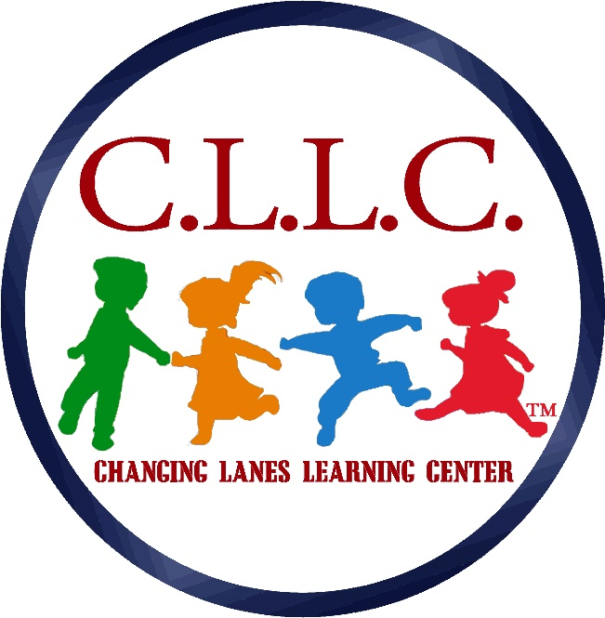

Changing Lanes Learning Center, LLC.
119 Chester Pike
Norwood, PA. 19074

01/1/2022

Dear Parents/Guardians/Caregivers

EMERGENCY EVACUATION

Our Emergency Operations Plan provides for a response to all types of emergencies. Depending on the circumstance of the emergency, we will use one of the following protective actions:
- Immediate evacuation Students are evacuated to a safe area on the grounds of the facility in the event of a fire
- In-Place Sheltering Sudden occurrences, weather or hazardous materials related, may dictate that taking cover inside the building is the best immediate response
- Evacuation Total evacuation of the facility may become necessary if there is a danger in the area. In this case, children will be taken to a Relocation Facility to be determined by Norwood Borough
- Modified operation May include cancellation, postponement, or rescheduling of normal activities. These actions are normally taken in case of a winter storm or building problems that may make it unsafe for students (such as utility disruptions) but may be necessary in a variety of situations

  - The administrators of Changing Lanes will review the emergency plan at least annually and update the plan as needed.
  - The administrators will document in writing each review and update of the emergency plan.
  - The administrators will assure that each facility person receives training regarding the emergency plan at the time of initial employment, on an annual basis and the time of each plan update.
  - The administrators will document the date of each training session and the names of all facility persons who received the training.
  - The administrators will post the emergency plan in the facility at a conspicuous location.
  - The administrators will send a copy of the emergency plan and subsequent updates to the county Emergency Management Agency.
  - The administrators will provide the parents/guardians/caregivers with a copy upon registration of their child(ren).

Please listen to KYW 1060 AM for announcements relating to any of the emergency actions listed above.

We ask that you not call Changing Lanes Learning Center during an emergency. This will keep the telephone line free to make emergency calls and to relay information.

We (or the Norwood Borough Emergency Operations Center) will let you know that we have taken one of these protective actions. We will also phone you when we have resolved the situation and it is safe for you to pick up your child/children.

The form designating persons to pick up your child/children will be the Emergency Contact Form that you filled out at the time of your child’s/children’s enrollment. This form is used every time that your child is released. We specifically urge you not to attempt to make different arrangements during an emergency. This will only create additional confusion and divert staff from their assigned emergency duties.

Please sign this page and return it by the end of your child’s second week.
I have read the Changing Lanes Learning Center, LLC. Emergency plan and agree to follow the policies contained in it. I also agree that by signing this form I have read and understand its content.

Child’s Name _____________________________

(Parent’s signature) ________________________

(Date) ______________________

