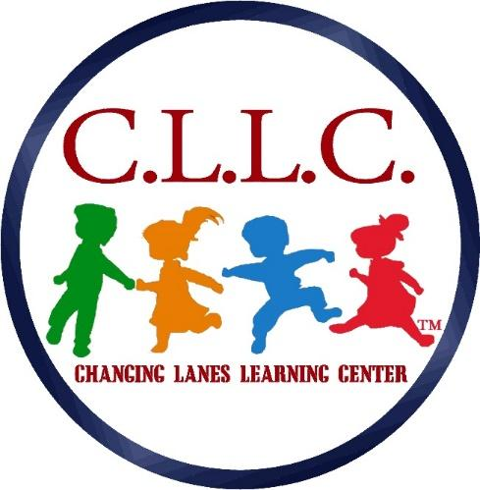
119 Chester Pike, Norwood, PA 19074
Phone: 610-237-0446 – Fax: 610-237-1909

WELCOME
We would like to formally welcome you to Changing Lanes Learning Center. We look forward to providing you and your child with quality care that you can depend on. This checklist should be helpful in getting your child ready for his/her first day at Changing Lanes. Remember, as always, if you have any questions, please feel free to give us a call.
Forms to complete for all new students:
- Registration Form
- Agreement Form
- Emergency Contact Form
- Health Appraisal (to be completed by a doctor)
- Getting To Know Your Child Information Form
- Photo Release Form
- IFP-IFSP Request Form
- CCIS Confirmation Form (if applicable)
- Emergency Evacuation Form
- COVID-19 Acknowledgement and Disclosure Form

Infants will need:
- At least 10 diapers
- Tub of diaper wipes
- Diaper creams or ointments if needed
- (2) complete changes of seasonally appropriate clothing
- (2) crib sheets
- (2) blankets
- (2) burp cloths
- (2) bibs
- Extra formula

Toddlers and Preschool-Aged children will need:
- At least 10 diapers (when applicable)
- Tub of diaper wipes (when applicable)
- Ointments or powders needed for diaper changes (when applicable)
- Complete change of seasonably appropriate clothing
- Lunch box w/ snack, lunch, and beverages
- Rest-time bag containing a crib sheet and small blanket

Take a deep breath- we will be here to help you and your child each step of the way as you become part of the Changing Lanes family.

