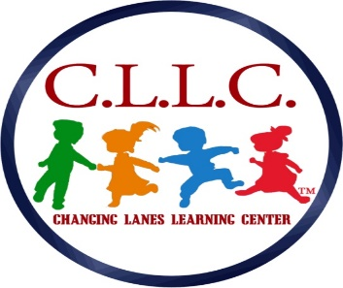
Changing Lanes Learning Center, LLC
Childcare Center
119 Chester Pike
Norwood, PA. 19074
School # 610-237-0446/Fax # 610-237-1909

E-mail: cllcnorwood@gmail.com

CCIS CONFIRMATION FORM

NAME: ____________________________________________________________________

CHILD(REN) & AGE(S) __________________________________________________________

___________________________________________________________

CCIS RECORD # ___________________________________________________________

CASE WORKER NAME: __________________________________________________________

CASEWORKER PHONE: ___________________________________________________________

CO-PAY: ______________________ POSSIBLE START DATE: ____________________

ADDITIONAL COMMNTS:_________________________________________________________

