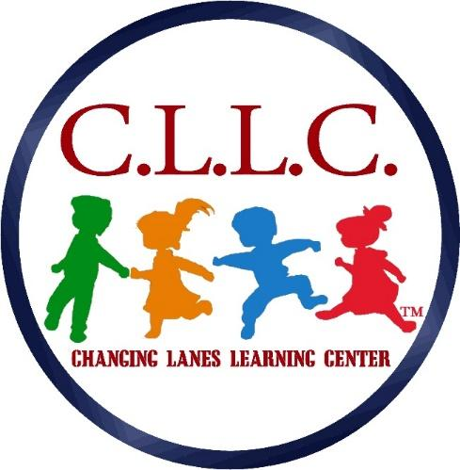
1200 Clifton Avenue
Collingdale, PA 19023
Phone: 610-522-2101 – Fax: 610-522-9103

Getting To Know You

Child’s Name:_________________________ Date:____________

Parent(s)/Family Section:

- Does your child have any parents that do not live in the home?
If yes, does your child visit this parent?

- Are there any custody issues that we should discuss?

- Does your child have any siblings (names and ages)?

- Does your child have any nicknames for family members?

- Is there any other information about your family’s composition that you would like to share?

- Is there any information about your child’s family culture, ethnicity, language, or religion that is important for us to know?
- What are your expectations of our program?

- Is there any particular aspect of an education program that is especially important to your child/ family?

- Do you have any questions about the Family Handbook?

- Do you have any questions about the program, curriculum, or facility?

Child Info Section :
- Has your child been in an early learning program or child care before?

If yes, would you share some information with us (Where? When? etc.)

Is there a reason for leaving that care that you would like to share with us?

- How does your child react to other children and adults?

- What do you anticipate will happen the first day that you leave your child with us?

- Are there any special problems or fears that we should know about?

- Is there any information that will help us make the first few days at CLLC easier for your child?

- Does your child have special needs (medical, developmental, social, mental health)?

If yes, do any of these special needs require special care from our teachers?

- Does your child have an IEP (Individualized Education Plan) or ISFP (Individualized Family Service Plan)?
If yes, what program/ individuals work with your child in regards to these special needs?

- Does your child have any allergies?
Food Allergies?
Environmental Allergies?
Medicine Allergies?
If yes, how are your child’s allergies treated?

- Do you have any special medical or dietary information for management in an emergency situation (medicine to keep on hand, people to call, etc.)?

- Any other medical or special needs?

- Describe your child’s schedule:
Normal waking time/ bedtime:
Nap time/s and duration of naps:
Meal times:

- Does your child do any of the following:
Nail biting?
Thumb sucking?
Stuttering?

- Regarding toileting habits:
Is your child toilet trained?
Does your child need to be reminded to go to the toilet during waking hours?
What words does your family use for bowel movements and urination?

- Tell us about your child’s
Favorite toys:
Favorite Games:
Food Likes and Dislikes:

- Does your child respond to any nicknames?

- Is there any other information you would like to share with us about your child?

Parent Signature:________________________________ Date: _______________

