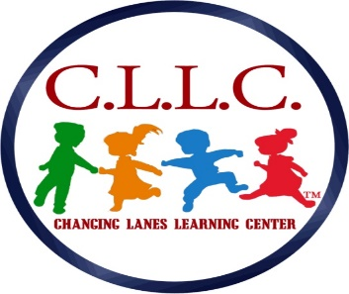
Childcare Center
119 Chester Pike
Norwood, PA. 19074
School # 610-237-0446/Fax # 610-237-1909
E-mail: cllcnorwood@gmail.com
PHOTO RELEASE FORM / 2021-2022

I, ______________________, hereby give Changing Lanes Learning Center LLC. with its authority, permission to reproduce, publish, circulate, or otherwise use any school pictures /videos of my child produced by Changing Lanes Learning Center, LLC. These photos/videos may be used in any promotional materials produced by Changing Lanes Learning Center, LLC. This also includes the permission to advertise them on our website at www.changinglaneslearningcenter.org

I hereby warrant that I am free to give this permission. I further warrant that the information I have provided is, to the best of my knowledge, true and accurate.

I do not want my child (ren)’s photograph to be used.

Please print parent/guardian name: ____________________________________________

_______________________________________________________________________
Signature of Parent/Guardian

_____________________________________________________
First and Last Name(s) of Student(s) Date(s) of Birth

Address

_______________________________________________________________________
Phone School Year

